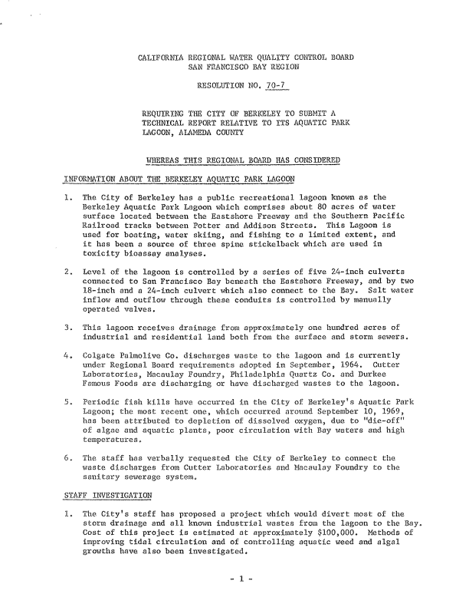
CALIFORNIA REGIONAL WATER QUALITY CONTROL BOARD
SAN FRANCISCO BAY REGION
RESOLUTION NO. 70-7
REQUIRING THE CITY OF BERKELEY TO SUBMIT A
TECHNICAL REPORT RELATIVE TO ITS AQUATIC PARK
LAGOON, ALAMEDA COUNTY
WHEREAS THIS REGIONAL BOARD HAS CONSIDERED
iNFORMATION ABOUT THE BERKE:CEY AQUATIC PARK LAGOON
1. The Oity of Berkeley has a public recreational lagoon known as the Berkeley Aquatic Park Lagoon which comprises about 80 acres of water surface located between the Eastshore Freeway and the Southern Pacific Railroad tracks between Potter and Addison Streets. This Lagoon is used for boating, water skiing, and fishing to a limited extent, and it has been a source of three spine stickelback which are used in toxicity bioassay analyses.
2. Level of the lagoon is controlled by a series of five 24-inch culverts connected to San Francisco Bay beneath the Eastshore Freeway, and by two l8-inch and a 24-inch culvert which also connect to the Bay. Salt water inflow and outflow through these conduits is controlled by manually operated valves.
3. This lagoon receives drainage from approximately one hundred acres of industrial and residential land both from the surface and storm sewers.
4. Colgate Palmolive Co. discharges waste to the lagoon and is currently under Regional Board requirements adopted in September, 1964. Cutter Laboratories, Macaulay Foundry, Philadelphia Quartz Co. and Durkee Famous Foods are discharging or have discharged wastes to the lagoon.
5. Periodic fish kills have occurred in the City of Berkeley's Aquatic Park Lagoon; the most recent one, which occurred around September 10, 1969, has been attributed to depletion of dissolved oxygen, due to "die-off" of algae and aquatic plants, poor circulation with Bay waters and high temperatures.
6. The staff has verbally requested the City of Berkeley to connect the waste discharges from Cutter Laboratories and Macaulay Foundry to the sanitary sewerage system.
STAFF INVESTIGATION
1. The City's staff has proposed a project which would divert most of the storm drainage and all known industrial wastes from the lagoon to the Bay. Cost of this project is estimated at approximately $100,000. Methods of improving tidal circulation and of controlling aquatic weed and algal growths have also been investigated.
- 1 -
